**VIT-AP University, Inavolu, Amaravati,**



**Andhra Pradesh-522237, India**

**AUTOMATED HEADLIGHT USING LED MATRIX SYSTEM**

**GUIDED BY: DR SUMESH EP**

**SENSE**

**ENGINEERING CLINICS REPORT**

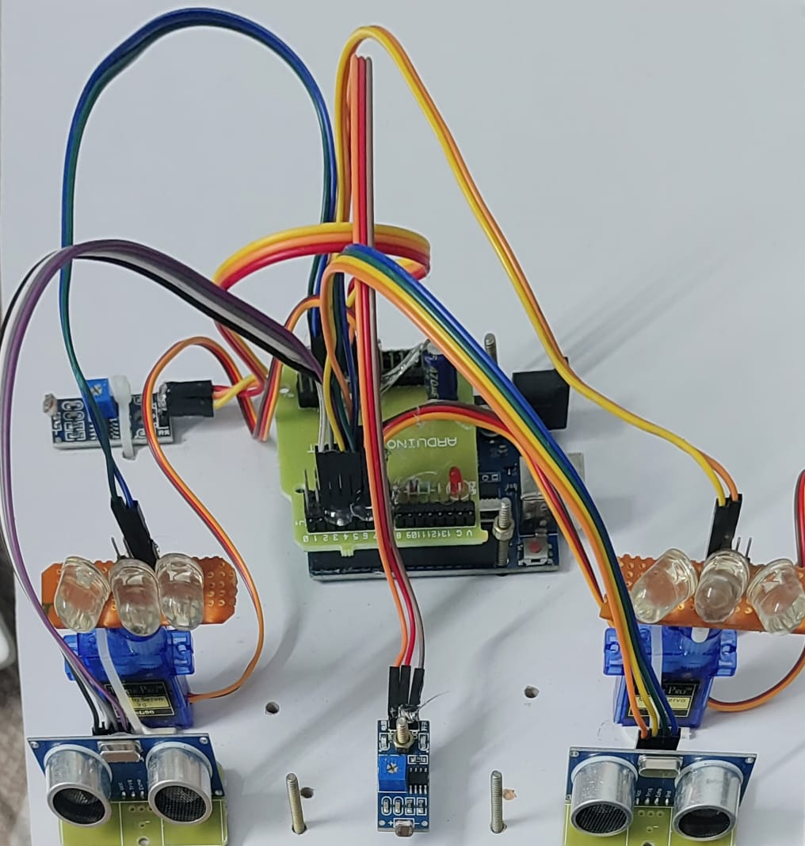

**TEAM MEMBERS**

|  |  |  |
| --- | --- | --- |
| **NAME** | **REGISTRATION NO** | **DEPARTMENT** |
| **EDUPULAPATI SAI PRANEETH** | **23BCE8762** | **SCOPE** |
| **MOOLE ASISH REDDY** | **23BCE8660** | **SCOPE** |
| **JUNAID SHAIK** | **23BCE8679** | **SCOPE** |
| **MAKAM JAYA CHANDRA** | **23BCE8665** | **SCOPE** |
| **LEKKALAPUDI THARUN** | **23BCE8698** | **SCOPE** |
| **REDDEM CHARAN REDDY** | **23BCE8237** | **SCOPE** |

**ABSTRACT:**

This project explores the design and development of an Automated Adaptive Headlight System aimed at significantly improving automotive safety, visibility, and driver comfort. Traditional vehicle headlights, while essential for nighttime and low-light driving, often pose challenges such as insufficient brightness in dark conditions and glare for oncoming traffic. To address these issues, this project introduces an intelligent headlight system that dynamically adjusts both brightness and direction, enhancing road illumination based on real-time environmental factors. The system integrates an LED matrix with adjustable intensity, controlled by MOSFET drivers, a Light Dependent Resistor (LDR) sensor to monitor ambient light levels, and servo motors for directional control.

The LDR sensor continuously monitors ambient lighting conditions, allowing the Arduino Uno microcontroller to process the data and adjust the LED brightness through MOSFET drivers. Additionally, servo motors dynamically orient the LED matrix based on vehicle position and road layout, optimizing lighting in response to changing driving conditions. This directional adaptability is particularly useful on winding roads and turns, ensuring optimal visibility where needed. A built-in glare reduction algorithm also detects oncoming vehicles and temporarily dims the headlights, enhancing safety for both drivers.

Overall, this system demonstrates an innovative approach to adaptive lighting by combining advanced sensor technology, microcontroller processing, and intelligent control algorithms. It is a cost-effective, flexible solution that enhances nighttime and low-light driving, reduces glare, and improves driver awareness. By integrating multiple hardware and software components, this automated headlight system sets a strong foundation for future advancements in adaptive and autonomous automotive lighting technologies, paving the way for safer, more responsive vehicles.

**INTRODUCTION:**

Automotive lighting technology has evolved to incorporate adaptive features that improve driver safety and comfort. Traditional fixed-beam headlights are limited in their ability to provide targeted illumination or reduce glare for oncoming vehicles. This project addresses these limitations by designing an **Automated Adaptive Headlight System** that intelligently adjusts both brightness and direction based on environmental conditions and traffic.

The primary functions of this system include:

1. **Brightness Adjustment**: Automatically controls LED brightness in response to ambient light levels, conserving energy during the day and enhancing visibility at night.
2. **Glare Reduction**: Detects oncoming vehicles and temporarily reduces brightness, providing a safer experience for oncoming drivers.
3. **Dynamic Directional Control**: Uses servo motors to adjust the LED matrix direction based on vehicle orientation and road layout, ensuring optimal visibility

**LITERATURE REVIEW:**

Recent advancements in adaptive headlight systems have shown significant improvements in driving safety and comfort. **Mace et al. (2001)** explored headlight intensity control for nighttime driving, emphasizing the need for systems that adapt to road conditions and reduce glare for oncoming traffic. Modern automotive lighting technologies, such as **Audi's Matrix LED headlights**, leverage adaptive lighting systems to focus beams on specific areas of the road, enhancing visibility while minimizing glare. Studies have demonstrated that adaptive systems not only improve safety but also reduce driver fatigue by minimizing high-beam usage. However, many existing systems are proprietary and expensive, underscoring the need for a cost-effective, open-source solution like the one proposed in this project.

**OBJECTIVES:**

1. **Develop Adaptive Headlight Brightness Control**: Design a headlight system that automatically adjusts LED brightness in response to changing ambient light conditions, enhancing visibility and energy efficiency.

2**. Implement Glare Reduction Mechanism**: Create a detection system for oncoming vehicles to reduce headlight brightness temporarily, minimizing glare and improving safety for other drivers.

3. Enable Dynamic Directional Lighting: Integrate servo motors to adjust the LED matrix's direction based on vehicle orientation, ensuring optimal road illumination, especially on turns and curves.

4. **Ensure Efficient System Integration**: Build a responsive, reliable system that combines sensors, LEDs, servo motors, and a microcontroller to operate cohesively.

**5. Enhance Automotive Safety and Driver Comfort**: Provide an adaptive lighting solution that improves night driving visibility, reduces glare, and increases overall driving comfort.

**HARDWARE COMPONENTS:**

* **LED Matrix Board**: A grid of LEDs with adjustable brightness and direction.
* **LDR Sensor**: Provides data on ambient light conditions to the Arduino.
* **MOSFET Drivers**: MOSFET transistors used to control the LED matrix’s brightness.
* **DC Motor**: Used for adjusting the orientation of the LED matrix to direct the light beam.
* **DC Motor Controller**: Interfaces between the Arduino and the DC motor, enabling precise control.
* **Ignition Key**: A switch that activates the headlight system only when the vehicle is running.
* **Arduino Uno Board**: Handles input from the LDR sensor, controls the MOSFET drivers, and manages the DC motor controller.

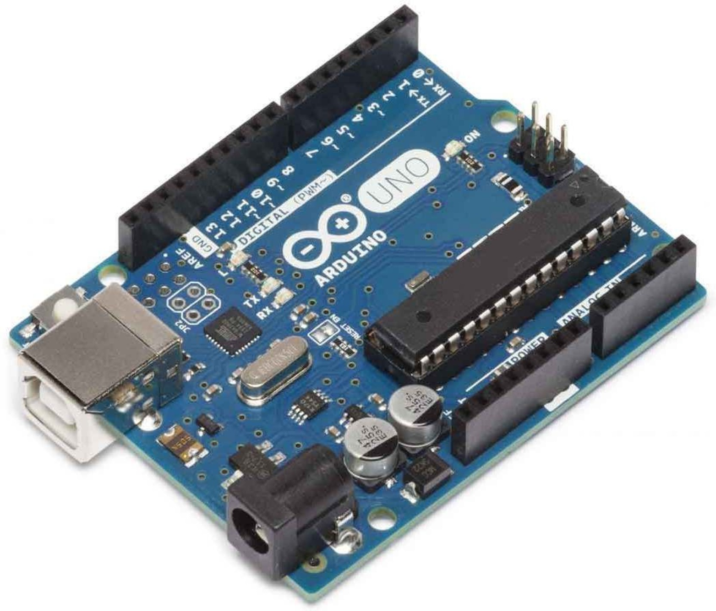 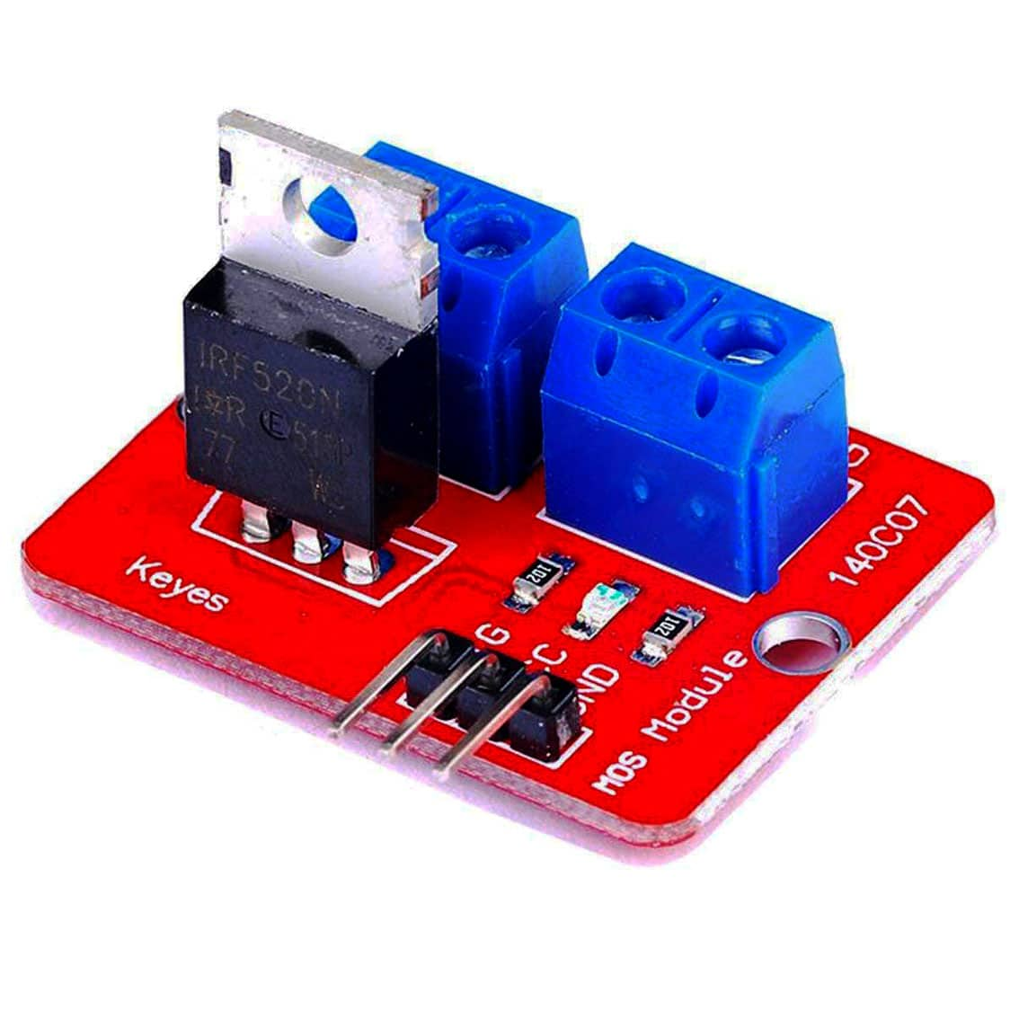 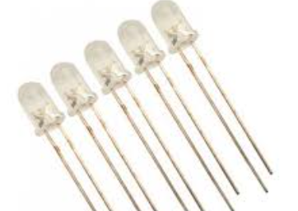 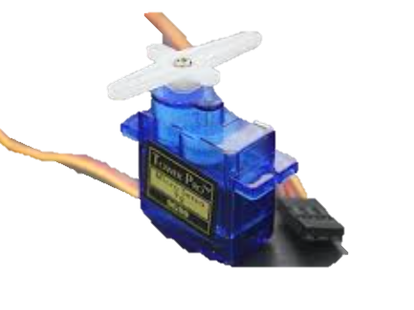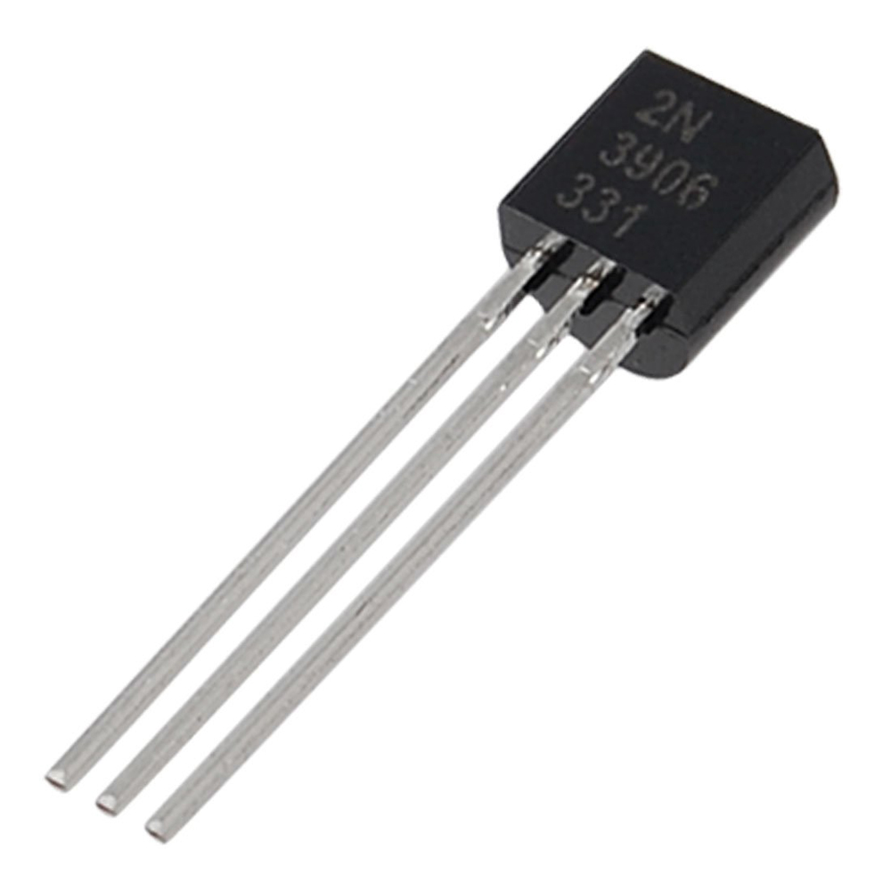

**ARDUINO UNO BOARD MOSFET DRIVERS LED BULBS DC MOTOTR TRANSISTORS**

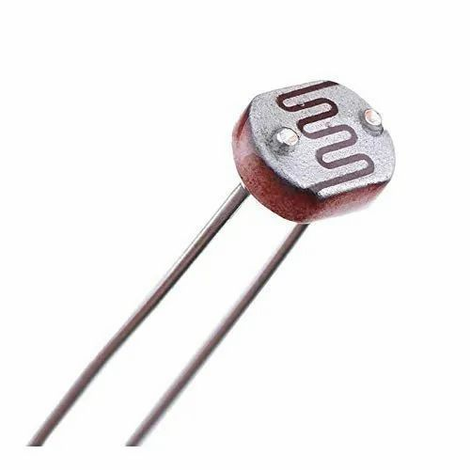  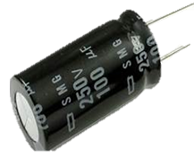 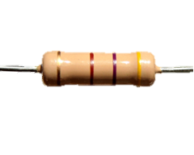 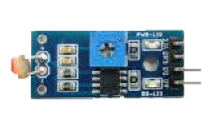 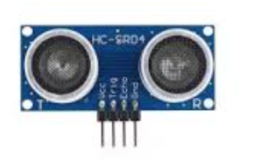

**LDR SENSOR CAPACITORS RESISTORS LDR MODEULE ULTRA SONIC SENSORS**

**SYSTEM ARCHITECTURE:**

The Automated Adaptive Headlight System consists of the following key components and subsystems:

1. LED Matrix: A grid of LEDs that supports adjustable brightness and direction.
2. LDR Sensor: Continuously measures ambient light levels and sends data to the Arduino, which then adjusts LED brightness.
3. MOSFET Drivers: Control the LED matrix brightness by adjusting current flow based on input from the Arduino.
4. Servo Motors: Precisely control the orientation of the LED matrix, responding to vehicle movement and road alignment.
5. Arduino Uno: Serves as the central processing unit, managing inputs from sensors and controlling outputs to MOSFET drivers and servo motors.

**SYSTEM WORKFLOW:**

1. The LDR sensor measures ambient light and sends this data to the Arduino.
2. The Arduino adjusts LED brightness through MOSFET drivers based on light conditions.
3. Servo motors adjust the direction of the LED matrix for optimal road illumination.
4. A detection algorithm reduces brightness when an oncoming vehicle is detected to minimize glare.

**SOFTWARE DESIGN:**

**Control Algorithm**

1. **Ambient Light Adjustment:**

* Continuously monitor light levels.
* Adjust LED brightness in real-time, increasing brightness in low-light conditions.

1. **Directional Adjustment Using Servo Motors:**

* Use servo motors to control LED direction, based on road and vehicle orientation.
* Respond to changes in steering or vehicle position to adjust lighting.

1. **Oncoming Vehicle Detection:**

* Use sensors to detect the presence of oncoming vehicles.
* Reduce LED brightness if an oncoming vehicle is detected to minimize glare.

**SOFTWARE IMPLEMENTATION:**

The system's software is implemented on the Arduino microcontroller using C/C++ for efficient data handling and response. Key software modules include:

* Sensor Data Processing: Captures and processes ambient light and vehicle detection data.
* Brightness Control: Modulates LED intensity based on ambient light.
* Servo Control Module: Manages precise movement of the LED matrix based on road conditions.
* Glare Reduction Algorithm: Temporarily reduces LED brightness to minimize glare for oncoming traffic.

**ALGORITHM:**

* Start: The algorithm begins with the system start.
* When it gets power, it goes to the next step.
* Read LDR Sensor: The system reads the ambient light level using the LDR (Light Dependent Resistor) sensor.
* Adjust LED Brightness Using MOSFET Drivers: Based on the LDR sensor reading, the algorithm adjusts the brightness of the LED matrix using MOSFET drivers.
* Adjust Light Direction Using DC Motor: The system adjusts the light direction using the DC motor to ensure optimal road illumination.
* Check Oncoming Vehicles?: The system checks for oncoming vehicles.
* Yes: If an oncoming vehicle is detected, the brightness is reduced to minimize glare.
* No: If no oncoming vehicles are detected, the system continues with the current settings

**FLOWCHART:**

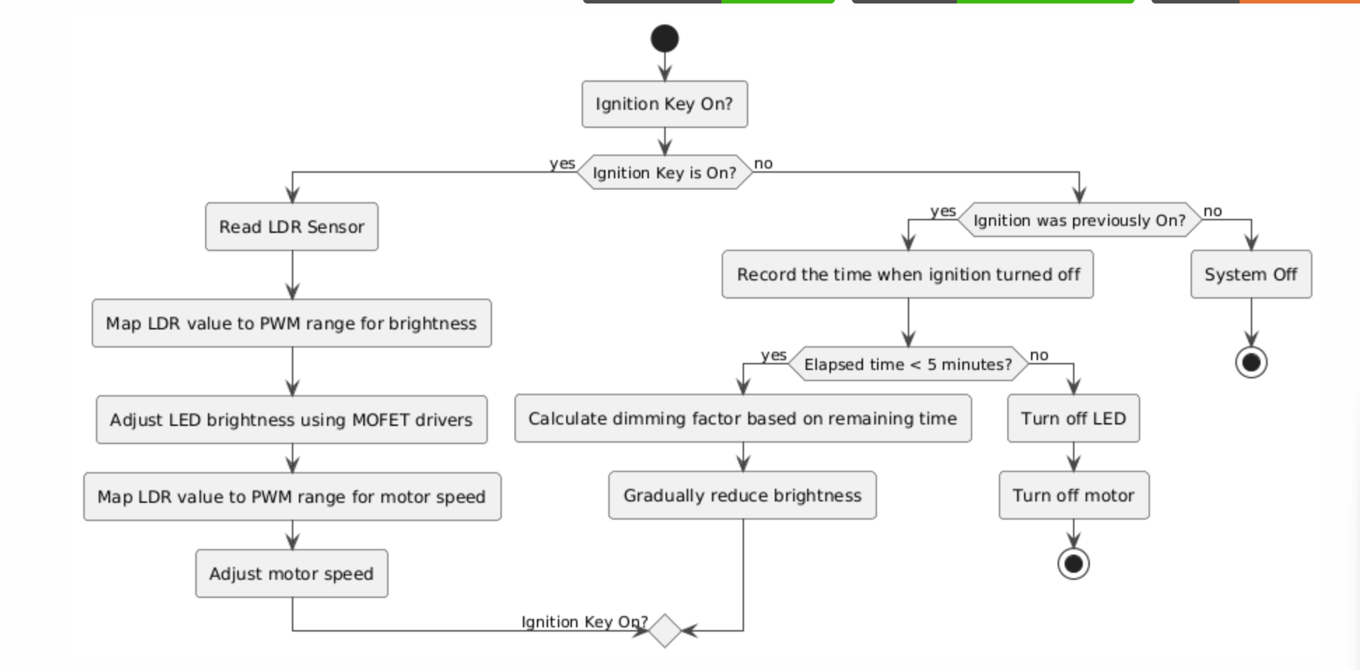

**CIRCUIT DIAGRAM:**

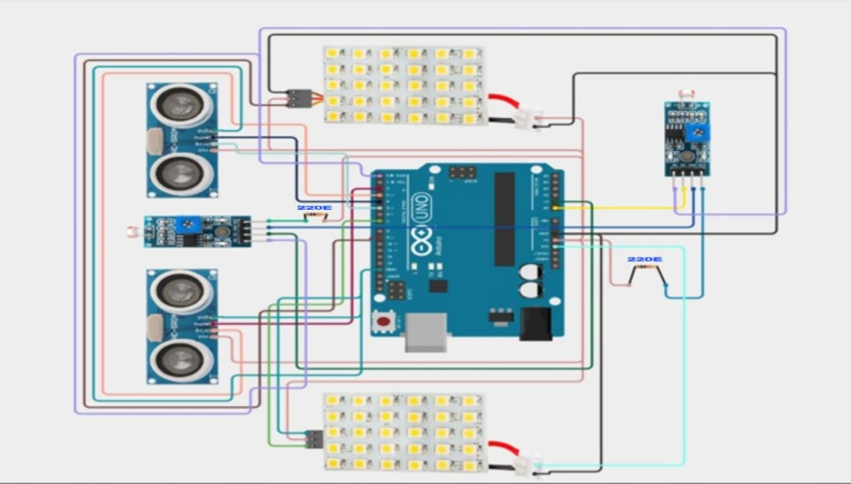

**BLOCK DIAGRAM:**

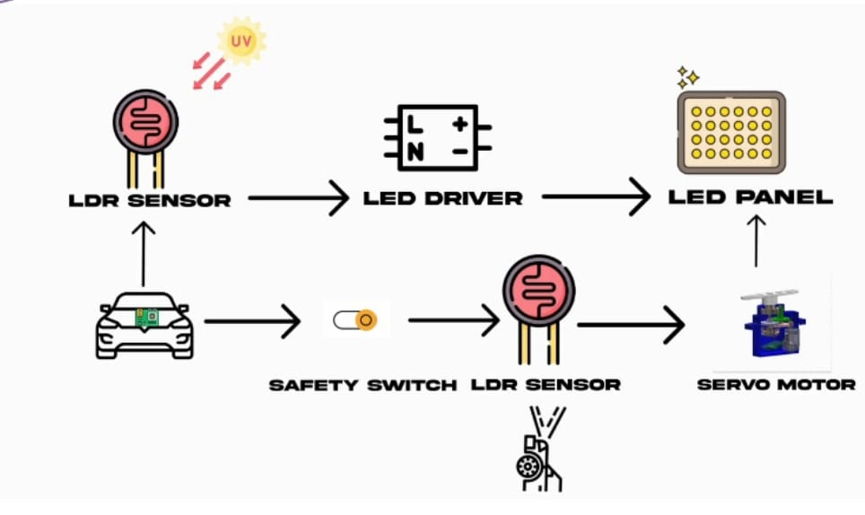

**TESTING AND VALIDATION:**

To ensure functionality and reliability, rigorous testing was conducted in simulated environments.

Test Scenarios

1. Brightness Adjustment: Tested in varying light conditions (day, dusk, night) to verify correct brightness adjustments.
2. Directional Control: Simulated turns and road curves to validate smooth and accurate servo motor response.
3. Glare Reduction: Simulated oncoming vehicles to test the system’s ability to detect and adjust brightness in real-time.

**TEST RESULTS:**

|  |  |  |
| --- | --- | --- |
| **Test Case** | **Expected Outcome** | **Result** |
| Ambient Light Adjustment | LED brightness adjusts according to light levels | Successful |
| Directional Control | LED matrix aligns with road and vehicle orientation | Successful |
| Oncoming Vehicle Detection | Headlight brightness reduces to prevent glare | Successful |

**ADVANTAGES AND DISADVANTAGES:**

|  |  |
| --- | --- |
| **Advantages** | **Disadvantages** |
| Reduce the glare from headlight glare of vehicles behind you | Can be expensive |
| Automatically adjust based on light intensity | May take some time to adjust |
| Improves safety, particularly during night driving | Complex system may require costly repairs  If they malfunction |

**PROJECT SOFTWARE:**

#include <LiquidCrystal.h>

#include <Servo.h>

Servo lservo;

Servo rservo;

LiquidCrystal lcd(8, 9, 10, 11, 12, 13);

#define ec1 2

#define tr1 3

#define ec2 4

#define tr2 5

int ldr = A1;

int ldr1 = A0;

int hl = A2;

int hr = A3

int lightThreshold = 600;

void setup() {

    Serial.begin(9600);

    pinMode(tr1, OUTPUT);

    pinMode(ec1, INPUT);

    pinMode(tr2, OUTPUT);

    pinMode(ec2, INPUT);

    pinMode(ldr, INPUT);

    pinMode(ldr1, INPUT);

    lservo.attach(7);

    rservo.attach(6);

    pinMode(hl, OUTPUT);

    pinMode(hr, OUTPUT);

    lservo.write(20); // Initial position for left servo

    rservo.write(0);  // Initial position for right servo

    lcd.begin(16, 2);

    lcd.print("    WELCOME");

    digitalWrite(hl, HIGH);

    digitalWrite(hr, HIGH);

}

void loop() {

    int leftLight = analogRead(ldr1);

    bool isLeftLightDetected = (leftLight > lightThreshold);

    digitalWrite(tr1, LOW);

    delayMicroseconds(2);

    digitalWrite(tr1, HIGH);

    delayMicroseconds(10);

    digitalWrite(tr1, LOW);

    int dst1 = pulseIn(ec1, HIGH) / 58.2;

    digitalWrite(tr2, LOW);

    delayMicroseconds(2);

    digitalWrite(tr2, HIGH);

    delayMicroseconds(10);

    digitalWrite(tr2, LOW);

    int dst2 = pulseIn(ec2, HIGH) / 58.2; // Distance for right side

    Serial.println("D1:" + String(dst1) + "   D2:" + String(dst2));

    lcd.clear();

    lcd.print("DL:" + String(dst1) + "  DR:" + String(dst2));

    if (dst1 < 10) {

        if (rservo.read() != 20) {

            for (int i = rservo.read(); i <= 20; i++) {

                rservo.write(i);

                delay(20);

            }

        }

    } else {

        if (rservo.read() != 0) {

            for (int i = rservo.read(); i >= 0; i--) {

                rservo.write(i);

                delay(20

            }

        }

    }

    if (isLeftLightDetected && dst2 < 10) {

        if (lservo.read() != 0) {

            for (int i = lservo.read(); i >= 0; i--) {

                lservo.write(i);

                delay(20);

            }

        }

    } else {

        if (lservo.read() != 20) {

            for (int i = lservo.read(); i <= 20; i++) {

                lservo.write(i);

                delay(20);

            }

        }

    }

    if (isLeftLightDetected) {

        digitalWrite(hl, HIGH);

        digitalWrite(hr, HIGH);

    } else {

        digitalWrite(hl, LOW);

        digitalWrite(hr, LOW);

    }

}

**CONDITIONS TABLE:**

Key Variables and Conditions

1. Left Light Detected: This indicates whether a light source is detected on the left side (leftLight > lightThreshold). When true, the left LEDs (hl) and right LEDs (hr) are turned on.
2. Ambient Light: Refers to the overall light level detected by ldr. If ldr value is above lightThreshold, it indicates a high ambient light condition; otherwise, it’s considered low.
3. Distance (dst1 and dst2):
   * dst1: The distance detected by the left ultrasonic sensor (in cm).
   * dst2: The distance detected by the right ultrasonic sensor.
   * If either dst1 or dst2 is less than 10 cm, the servos on that side adjust to a specific position for obstacle avoidance.

Servo Positions and LED States

The actions for each condition depend on a combination of detected light, ambient light, and distances.

* Servo lservo: Controls the left side.
  + Moves to position 0 if there’s an object within 10 cm (dst2 < 10) and light is detected on the left.
  + Otherwise, it returns to its starting position of 20.
* Servo rservo: Controls the right side.
  + Moves to position 20 if there’s an object within 10 cm on the left (dst1 < 10).
  + Otherwise, it returns to position 0.
* LEDs hl and hr: Represent lighting on the left and right, respectively.
  + Both LEDs are turned on when light is detected on the left.
  + They remain off when no light is detected on the left, regardless of ambient light.

|  |  |  |  |  |  |  |  |
| --- | --- | --- | --- | --- | --- | --- | --- |
| LEFT LIGHT DETECTED | AMBIENT  LIGHT | DIST1<20 | DIST2<20 | LSERVO | RSERVO | H1(LED LEFT) | H2(LED RIGHT) |
| YES | HIGH | YES | YES | 0 | 20 | HIGH | HIGH |
| YES | HIGH | YES | NO | 0 | 0 | HIGH | HIGH |
| YES | HIGH | NO | YES | 20 | 20 | HIGH | HIGH |
| YES | HIGH | NO | NO | 20 | 0 | HIGH | HIGH |
| YES | LOW | YES | YES | 0 | 20 | HIGH | HIGH |
| YES | LOW | YES | NO | 0 | 0 | HIGH | HIGH |
| YES | LOW | NO | YES | 20 | 20 | HIGH | HIGH |
| YES | LOW | NO | NO | 20 | 0 | HIGH | HIGH |
| NO | HIGH | YES | YES | 0 | 20 | LOW | LOW |
| NO | HIGH | YES | NO | 0 | 0 | LOW | LOW |
| NO | HIGH | NO | YES | 20 | 20 | LOW | LOW |
| NO | HIGH | NO | NO | 20 | 0 | LOW | LOW |
| NO | LOW | YES | YES | 0 | 20 | LOW | LOW |
| NO | LOW | YES | NO | 0 | 0 | LOW | LOW |
| NO | LOW | NO | YES | 20 | 20 | LOW | LOW |
| NO | LOW | NO | NO | 20 | 0 | LOW | LOW |

**SUMMARY:**

Servo Movements: The servos adjust positions based on proximity and light. If obstacles are close, they change positions to possibly avoid or signal. The presence of light on the left further affects the left servo's movement.

LED Control: LEDs turn on when left light is detected, regardless of ambient light. The system thus differentiates between direct light from a vehicle and general ambient light.

Ambient Light Influence: Ambient light does not directly affect behaviour but could provide context for additional modifications**.**

**BUDGET:**

|  |  |
| --- | --- |
| **Components** | **Price** |
| Arduino Uno | 350 |
| Mosfet Drivers | 200 |
| Led bulbs | 100 |
| Servo Motor | 300 |
| Transistors | 150 |
| Capacitors | 150 |
| Resistors | 100 |
| Ldr Module | 50 |
| Ultra Sonic Sensors | 300 |
| Others | 700 |
| Total | 2500(Approx) |

**PROJECT TIMELINE:**

To develop a working model of this project, our team requires approximately one month. This timeline includes all phases of development, from initial design and prototyping to rigorous testing and refinement. We will ensure that each component is thoroughly evaluated to meet the project’s specifications and quality standards. Additionally, our team will be closely monitoring progress to address any challenges that arise and make necessary adjustments to stay on track.

|  |  |  |  |
| --- | --- | --- | --- |
| **Task** | **Review 1** | **Review 2** | **Review3** |
| Project Planning | ✓ |  |  |
| Data collection |  | ✓ |  |
| Project modelling |  | ✓ |  |
| Performance Evaluation |  |  | ✓ |
| Final Product |  |  | ✓ |

**PROJECT IMAGES:**

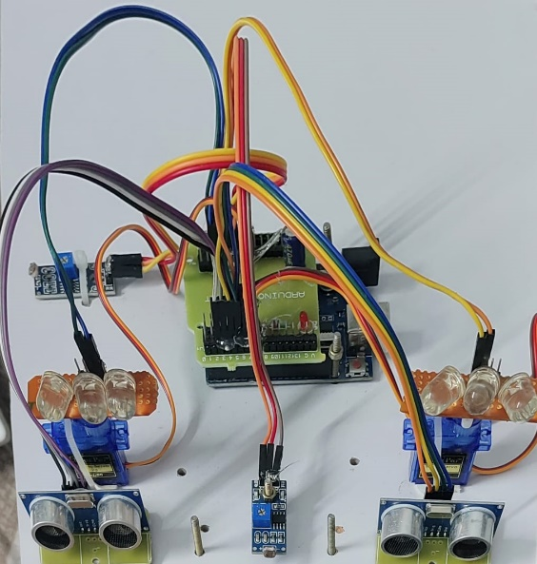

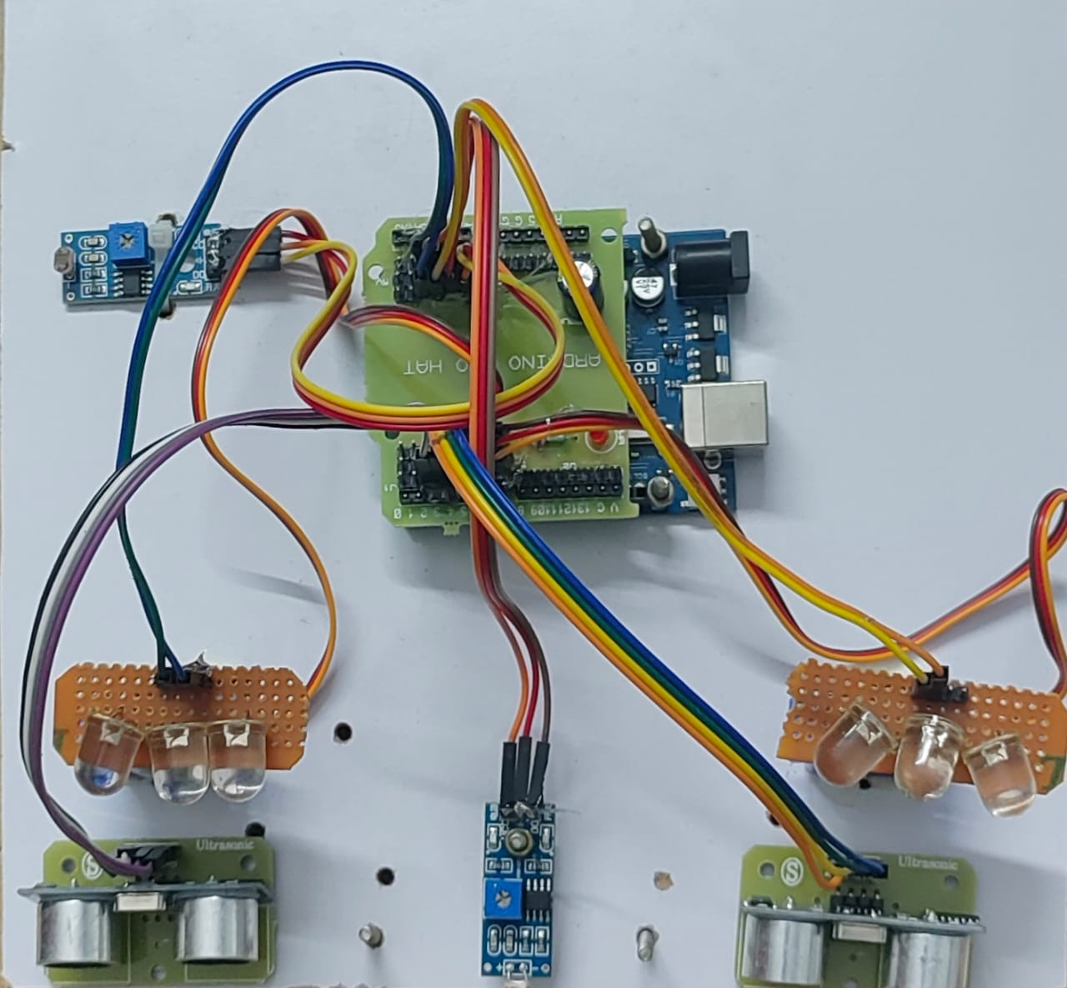

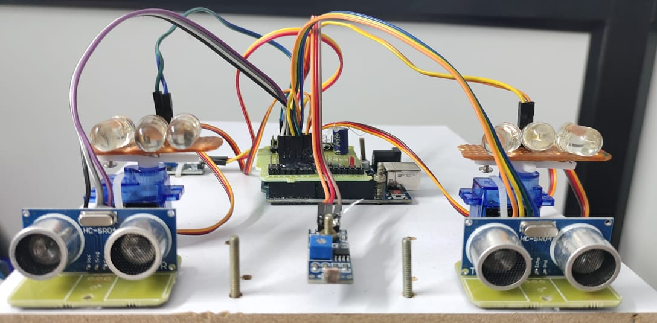

**PRECAUTIONS:**

1. Electrical Safety: Ensure correct wiring, use a stable power supply, and avoid static discharge to protect components.
2. Component Handling: Handle components like MOSFETs and Arduino carefully; disconnect power before adjusting servo motors.
3. Secure Connections: Double-check wiring and use appropriately rated cables to prevent malfunctions or overheating.
4. Ventilation: Allow for proper ventilation to avoid overheating of LEDs and other components.
5. Controlled Testing: Test in a safe, controlled environment before installation in a vehicle.
6. Motor Calibration: Calibrate servos for smooth movement and avoid forced adjustments to prevent damage.
7. Power Management: Use a reliable battery, matching power needs to ensure steady operation.
8. Glare Sensitivity: Adjust glare reduction carefully to balance visibility and safety.
9. Weatherproofing: Protect all components from moisture, dust, and vibration for vehicle installation.
10. Routine Maintenance: Regularly check and recalibrate components to ensure ongoing accuracy and performance.

**FUTURE WORK:**

This project establishes a foundation for adaptive headlight technology in automotive applications. Future improvements may include:

* Enhanced Detection Capabilities: Integrating camera-based detection for a wider field of view and more accurate detection of road obstacles.
* Wireless Connectivity: Enabling the system to connect with other vehicle systems for coordinated lighting control.
* Integration with Navigation Systems: Adjusting light direction based on real-time navigation data for optimized road illumination.
* Power Optimization: Using energy-efficient components and adaptive algorithms to reduce power consumption further.

**RESULTS:**

1. Brightness Control: The system accurately adjusted LED brightness based on ambient light, improving visibility in low-light and energy efficiency.
2. Glare Reduction: Oncoming vehicle detection effectively reduced headlight brightness, minimizing glare for other drivers.
3. Directional Control: Servo motors smoothly directed the LED matrix to align with vehicle orientation, enhancing road illumination on curves.
4. System Integration: Components worked seamlessly, providing fast, responsive lighting adjustments.
5. Energy Efficiency: Dynamic brightness and directional control reduced energy consumption, preserving battery life.
6. Real-World Testing: Simulated tests showed improved visibility and safety, meeting project objectives for adaptive automotive lighting.

**CONCLUSION:**

The **Automated Adaptive Headlight System** leverages LED matrix control, servo motors, and sensor-based algorithms to deliver a safer and more comfortable driving experience. The system dynamically adjusts brightness and orientation based on environmental conditions, enhancing driver visibility and minimizing glare for other road users. This project demonstrates the potential for cost-effective, adaptive headlight technology, paving the way for future innovations in automotive lighting.

**REFERENCES:**

1. AUTHORS: Douglas Mace, Philip Garvey, Richard J Porter, Richard Schwab, Werner Adrian

PUBLISHED YEAR:2001

LINK: <https://scholar.google.co.in/scholar?q=related:Y0woJH6GMn0J:scholar.google.com/&scioq=headlight+literature+survey&hl=en&as_sdt=0,5&as_vis=1#d=gs_qabs&t=1723485670620&u=%23p%3DY0woJH6GMn0J>

1. COMPANY: AUDI MOTORS

LINK:

<https://www.audi-technology-portal.de/en/electrics-electronics/lighting-technology/matrix-led-headlights>

1. COMPANY LINKS

<https://youtu.be/F4-iwuzAey4?si=7GmxGWhjKo3uoDgG>

<https://youtu.be/fIKZ6aKgIlQ?si=-FGhvs2taFlj0m1x>